(Form 1)
No.
*Leave blank.
To the Management Office for the Project of Decommissioning, Contaminated Water and Treated Water Management

Application for the subsidies for the “Project of ________”

Applicant | Corporation number (*)
 | Company/Organization Name
Representative
(Full Name and Title)
 | Address
Contact | Contact Person  (Full Name)
 | Section/Department
 | Title
Telephone
(Extension, if any)
 | E-mail
* If a corporation number in Japan has been given, fill in the 13-digit number.
If you are an individual and foreign company, etc., not having it, leave the field as it is.
(Exhibit)

1. Name of the Subsidized Project

2. Objective and contents of the Subsidized Project
＊Describe your own understanding of the background of the project, the purpose of the project and its contents briefly.

3. Scheduled commencement and completion dates of the Subsidized Project
(Scheduled commencement date):
(Scheduled completion date):

4. Entire costs needed for the project JPY

5. Costs subject to subsidy JPY

6. Subsidy amount to be applied for JPY

7. Allocation amount of the costs for the Subsidized Project, costs eligible for the subsidy and subsidy amount to be applied for
The contents are the same as (2) Expenditures, I. Summary table of “2. Plan of the income and expenditure of the Subsidized Project” of the Form 2, “Brief explanation of subsidized project”.
8. Bases for Calculation for the above amount
The contents are the same as (2) Expenditures, II. Distribution of Costs of “2. Plan of the income and expenditure of the Subsidized Project” of the Form 2, “Brief explanation of subsidized project”.

9. If a group is formed to conduct the Project, the names of the group and the member companies
Note 1: The “costs required for the Subsidized Project” refers to the cost required for performance of the relevant project. As a general rule, the amount must be provided after deducting the amount of the national and local consumption taxes.
Note 2: As for the amount of the “Subsidized Costs”, as a general rule, the amount of the “costs required for the Subsidized Project” eligible for the Subsidy must be provided after deducting the amount of the national and local consumption taxes.
Note 3: The “amount of the Subsidy applied for” refers to the amount of the “Subsidized Costs” for which grant of the Subsidy is requested, and the amount limit is the amount of the “Subsidized Costs” multiplied by the Subsidized Ratio (any amount less than 1 JPY shall be rounded down).
Remark: The size of the paper used shall be the Japanese Industrial Standards A4 Format.
(Form 2)

Address
Name (Name of Corporation and Title/Name of Representative Person)

Outline of Subsidized Project

1. The implementation plan for the Subsidized Project (based on the period in above “4. Project Term”)
(1) Contents and implementation method of the project
＊(In the case of making a partial proposal in a solicitation where partial proposals are permitted) Provide the implementation items to be proposed.
＊Provide the following information by project content item.
＊Specific implementation contents and method, based on clarification of issues for each objective of research and development
＊Specific implementation content and method for each item of the project content
＊Specific proposal to improve outcome of the project
＊Project location (Address and name of the location)

(2) The implementation schedule
＊Describe the implementation schedule of the project by month for each implementation contents.
＊Describe the implementation procedure in detail. If the stages of the research and development are different (such as design, development, tests, etc.) in each item, describe the difference clearly.
＊If the persons in charge of the research and development (manufactures and subcontractors) are different in each item, describe the organization they belong to clearly so that we can distinctly understand who will actually implement the item.
＊Set the actual targets for achievement of the project purpose as milestones and describe them for each item.
＊In setting the milestones, they must be related to the points where delay of the project is foreseen.
＊In order to prevent delay, alternative options must be described for items with high risk.
＊Describe major output and input information so that correlation with other projects, comprehensive proposals, partial proposals, etc. can be grasped.
＊As a plan of the interim report, describe the outputs which will have been able to be achieved at the time of the report and further plan.
＊In reporting your progress, show your plan and actual progress in a comprehensible manner. Furthermore, describe the up-to-date situation and further work plan, etc. as a reference.

(3) The project implementation organization
＊Provide the implementation organization chart and the number and role of people who are engaged in the project for each item of the project contents (Annex 1, Annex 2)
＊After clarifying the responsible person for entire project implementation, the project leader (exclusively employed for the project) and sub-leaders responsible for each project item, provide their profile, area of expertise and experience of engagement in similar projects..
＊Describe outsourcing or commissioning, if planned.
＊Describe the name, outline, year, ordering party, etc. of similar projects. If the project was done as your own company’s project, state it accordingly.
＊Clearly state the experiences of each participating party if you form a consortium.

2. Plan of the income and expenditure of the Subsidized Project (based on the period in above “4. Project Term”)

(1) Income (Unit: JPY)
Item | Amount
Own fund
*Bond issuance or borrowing
Other
Subsidy
Total
*Attach the documents to show the funding plan relating to the relevant bond issuance or borrowing.

(2) Expenditures
I. Summary table (Unit: JPY)
Classification of costs | Costs required for the Subsidized Project | Subsidized Costs | Classification of the cost burden
 |  |  | The amount of cost borne by the Subsidized Project Operating Entity | The amount of the Subsidy applied for
Labor Cost
Operating cost
Total

II. Distribution of Costs (provide the details by project item)
＊Describe in this sheet or other separate sheets the name of the goods, unit price, man-hour, etc. as basis for the calculation.
＊If you form a consortium, clearly describe the breakdown of each company or organization.
(Unit: JPY)
Type  (Example) | The cost required for the Subsidized Project | Subsidized costs | Amount of the Subsidy applied for | Remarks
【Labor Cost】
・・・
Sub total
【Operating Cost】
Raw material
Goods purchase
Outsourcing
・・・
Sub total
Total

(Note 1) The “cost required for the Subsidized Project” refers to the cost required to perform the relevant project. As a general rule, provide the amount after deducting the amount of the national and local consumption taxes.
(Note 2) As a general rule, provide the “Subsidized Costs”, which is eligible for the Subsidy after deducting the amount of national and local consumption taxes in the “cost required for the Subsidized Project”.
(Note 3) The “amount of the Subsidy applied for” refers to the amount of the “Subsidized Costs” for which grant of the Subsidy is requested, and the amount limit is the amount of the “Subsidized Costs” multiplied by the Subsidized Ratio (any amount less than 1 JPY shall be rounded down).

Remark: The size of the paper used shall be the Japanese Industrial Standards A4 Format.

3. Financial basis and management structure
＊Describe the outline of your organization; moreover, describe the grounds on which your organization has necessary management basis for smooth implementation of the project as Annex 2.
＊Describe the grounds on which your organization is capable of managing funds, etc. (such as organization and storage of evidence documents for expenditures). Furthermore, describe the scheme of the management of the funds (responsible persons and their roles).
＊If you form a consortium, all of the above-mentioned items must be described regarding every organization.

(Annex 1) The Implementation Organization Chart
Implementation Organization Chart
Content of the descriptions | - Develop an organization chart to show the framework for implementation of the Project  - The names, titles and division of roles of the personnel in charge must be contained in the implementation organization chart  - Clarify persons exclusively employed for this project described in this Chart; and describe the career background, expertise, area of specialty at work, qualification associated with the project, and other relevant information must be provided about the key personnel.

Operational Implementation Organization
*A concrete description should be provided by showing an implementation organization chart containing the following information for each project item.
*Specify the name of the contact person in case of a joint application
Leader
Name
Title
Role
Qualification
Sub-leader
Name
Title
Role
Qualification
Member
Name
Title
Role
Qualification
Member
Name
Title
Role
Qualification
・Name
・Title
・Role in this Project, etc.

(Annex 2) Outline of your organization
Note: If you form a team and apply, you must fill in this sheet for every participant.
*Fill in the data of the latest accounting year in non-consolidated base.
Company name
Title/name of the representative person

Contact information | Tel: Fax:  E-mail:
Head office’s address
Date of establishment | Date: | Account closing month |  |  | Small- or medium-sized company (indicate by a circle if the company is a small- or medium-sized company) | ○ or ×
Capital | JPY in thousands | Number of Employees
Description of business
Major shareholders  (equity ownership) | ○○○ (company limited) (60%)  ▽□○ (company limited) (30%)  □○○ (company limited) (1%)
(The title and name of the person responsible for above information:
Head of the XX Department, XX XX(Name))

Please provide the information about all officers in the list below:
Full name | Date of Birth |  |  | Gender | Company Name | Title
 | Year | Month | Day
(Example) Taro Keizai | 19XX | 01 | 01 | M | Keizai Sangyo Co., Ltd. | President & Representative Director

(Note 1) Add the columns as appropriate if the provided columns are not sufficient to provide full information.
(Note 2) Use M for male and F for female in one-byte characters to indicate the gender.
(Note 3) For a joint application or a consortium, provide the information about all officers of each and every member (company or otherwise) of the group.

(Remarks) The size of the paper used shall be the Japanese Industrial Standards A4 Format.

(Other documents)

(1) Outline of the company or organization such as a brochure, etc.
(2) The financial results, and statement of revenues and expenses (for the past one year)
(3) The articles of association or the act of endowment
(4) Other supporting documents (as needed)

(Form 3)
Certificate of Conformance to Qualification Requirements for
the Project of ________

I confirm that the applicant satisfies the qualification requirements for this subsidized project.
No. | Requirements | Verification, etc.
(1) | Possessing the organization for properly conducting the relevant subsidized project. If the case to subcontract to or jointly implement with a third party a part of the subsidized project, for the creation of project outcome, the appropriate cooperation structure should be established to manage the project. | <State that the applicant satisfies the requirements with reasons in detail ><See Form 2 “1. (3) Project Implementation Organization” when necessary.”>
(2) | Having the capacity, knowledge and experience required for conducting the relevant subsidized project. | <State that the applicant satisfies the requirements with reasons in detail ><See Form 2 “1. (3) Project Implementation Organization” when necessary.”>
(3) | Having the management foundation required for smoothly conducting the relevant subsidized project and sufficient ability to control the funds and other resources. | <State that the applicant satisfies the requirements with reasons in detail ><See Form 2 “3. Financial basis and management structure when necessary.”>
(4) | Being able to implement the project in accordance with all the applicable laws and regulations enacted in Japan, and to follow the appropriate accounting procedures in accordance with ”Grant Policy for Subsidy for the Project of Decommissioning, Contaminated Water and Treated Water Management” and “Subsidized Project Administration Manual”.  https://en.dccc-program.jp/files/20230224man.pdf | <State that you understand the statement on the left>
(5) | Not foreseen to be subject to Articles 70 and 71 of the Cabinet Order concerning the Budget, Auditing and Accounting. | <State that it does not apply to the applicant>
(6) | Not fulfilling any of the conditions stipulated in the “Guidelines for the suspension of subsidies controlled by the Ministry of Economy, Trade and Industry and the suspension of designation relating to the contracts”.（January 29, 2003, No 1）First column, the second items in Attachment | <State that it does not apply to the applicant>
(7) | Research and development companies which may require approval under the Foreign Exchange Act for any exports and imports should have an establishment of internal compliance program(ICP) under a self-control system about the "standards for exporters, etc. to meet" provided for in Article 55-10 (1) of the Foreign Exchange and Foreign Trade Act. | <Describe meeting this condition in the Form 5>
(8) | Admitting that the results obtained through this project can be utilized by TEPCO Holdings, Incorporated, etc. to leverage them for Decommissioning, Contaminated Water and Treated Water Countermeasures if they request to do so under the condition that each party is in agreement. Not preventing the utilization by behaviors such as not admitting use of the technology intentionally, asking for unreasonable compensation, etc. in spite of receiving the request. | <State that it is possible>
(9) | In order to make sure of the above-mentioned item, preventing the situation that the results from this project are not able to be utilized for measures for decommissioning, contaminated water and treated water management at the Fukushima Daiichi NPS by ceding the above-mentioned condition in (8) to the successor if the applicant hands over the result to a third party and loses their own right to utilize it accordingly. In the case of a conflict which makes the applicant unable to make sure of the items in (8), the concerned parties must solve it by their own responsibility. | <State that you understand the statement on the left>

<Note for Filling out this Form>
In the verification columns, please write the reasons why you verified that the applicant meets the requirements. When filling it out, write “Attachment” if there are any verification documents attached to this form and if not, write “No attachment.”

（Form 4）

Input/Output information on Project of ________________

＊Please refer to the reference document 1 as an example.

ID | Requested projects | Offered projects | Contents (outline) | Time when the information is necessary | How to use the information | Remarks
 |  |  |  | *Influences of delay (if any) |  | Such as measures for the case when you cannot ensure the accuracy, cannot keep the timeline, etc.

(Form 5)

Response to Security Export Controls on Project of ___________

Response to Security Export Controls
Circle one of the following three options: handled, not handled or not required.
Handled | Submit relevant documents (export control regulations for security trade)
Not handled | State the date of submission: Year Month:
 | State future plans
Not required | State reasons

(Form6)

Personal Data Processing Consent Form

Purposes
In compliance with the Act on the Protection of Personal Information, Mitsubishi Research Institute, Inc.(“MRI”) requests your consent to use your personal data to evaluate of proposal.

Data Sharing
MRI may share your personal data with cooperating organizations.

Data Retaining
There are cases in which it is necessary to retain your personal data for the necessary period according to the requirements of Japanese law.

Data Management
MRI will protect your personal data securely, including taking necessary measures to prevent leakage, loss, falsification, etc.

I have understood the above and give my consent to MRI to use my personal data for the above Purposes, and to carry out the above Data Sharing and Data Retaining.
Your Full name
Your Signature
Date

If you wish to modify your personal data or withdraw this consent after submission, please notify us by email to privacy@mri.co.jp.

Mitsubishi Research Institute, Inc.
10-3, Nagata cho 2-chome, Chiyoda-ku, Tokyo, Japan
privacy@mri.co.jp
PMS05_20180718

(Reference Document 1)

Table 1 Example of Organization of Input/Output information

ID | Requested projects | Offered projects | Contents (outline) | Time when the project is necessary | How to use the information | Remarks
1_1 | Advancement of Fundamental Technologies for Retrieval of Fuel Debris and Internal Structures | Development of Technologies for Containing, Transportation and Storage of Fuel Debris / Development of fuel debris criticality control technology | Size and specification of container and criticality detection device | April 2017 | Examination of possibility  of fuel debris sampling technology
1_2
1_3
1_4 | … | … | … | … | … | …

(Reference Document 2)

Table 1 Example of implementation schedule with points of attention
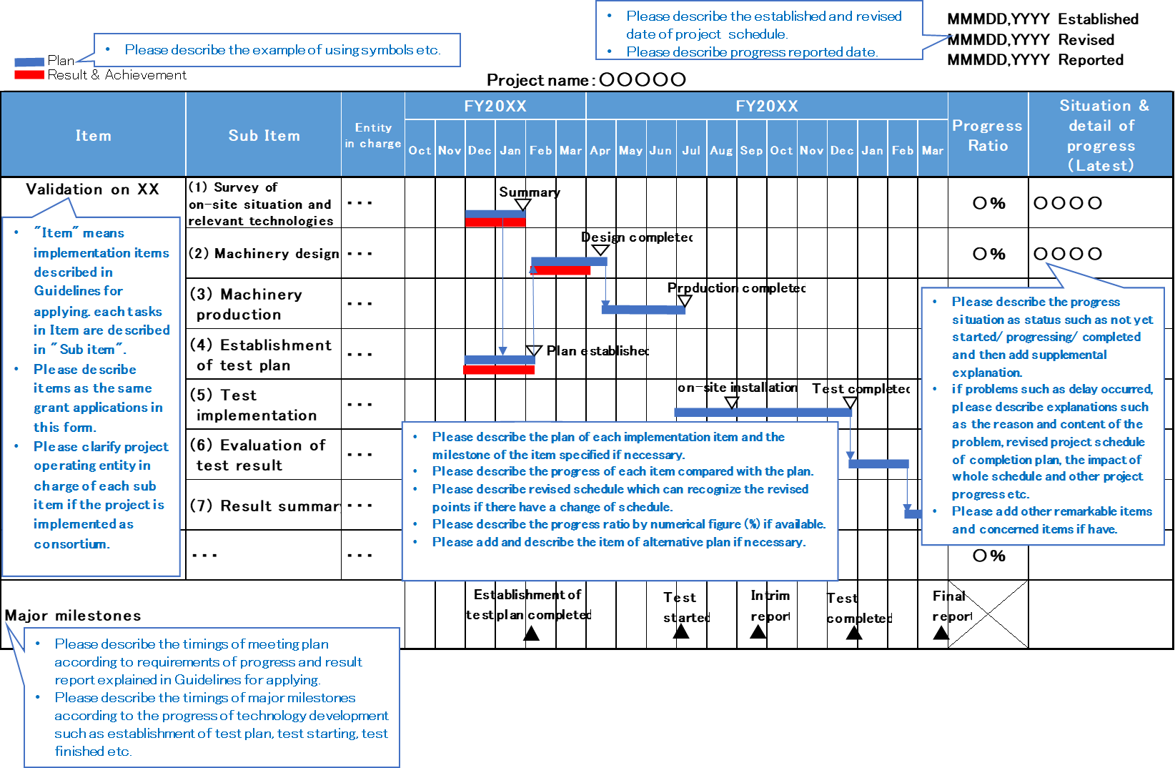

(Reference document 3)
Regarding Subsidized Cost Items

Regarding the cost items defined in “The Decommissioning, Contaminated Water and Treated Water Management Project Implementation Guidelines”, please refer to the following table.

Cost item | Description | Correspondence with “Subsidized Project Administration Manual”
I. Labor cost | Labor cost for working hours of those engaged in the project. | 3. Accounting process on labor cost
II. Operating cost
Raw material cost | Expenses necessary for purchasing raw material or material necessary for implementing the project  ※Here, “raw material” denotes what loses its nature and is used for production or manufacturing of entirely new ones; “material” denotes what does not lose its nature and is a constituent element of produced items or manufactured items only through being put to new application. | 7. Accounting procedures regarding supplies expenses
Supplies expense | Cost for the purchase of goods necessary for performing the project but not belonging to raw material cost (however, only those verifiable for the use in the project) | 7. Accounting procedures regarding supplies expenses
Design, production and  processing costs | The thing which the subsidized entity cannot design, produce or process, or the cost necessary for outsourcing what is appropriate and does not belong to Facility and equipment cost to other entity. (contract for work) | 11. Accounting procedures regarding expenses for commission fee/outsourcing cost
Facility and equipment cost | Cost necessary for purchasing, production or installation of facility or equipment necessary for undergoing the project  ※The actual contents of the “facility and equipment” shall be “buildings and accompanying facilities”, ”structures” and “machinery and equipment” stipulated in “Ministerial Order regarding depreciable life of depreciable assets, etc.” (Fifteenth Order of Ministry of Finance, 1965). | 6. Accounting procedures regarding equipment expenses and rental and hire  fees  11. Accounting procedures regarding expenses for commission fee/outsourcing cost
Procurement cost | Cost for the thing which is necessary for undertaking the project and does not belong to facility and equipment cost (at the same time, can be usable more than one year) | 6. Accounting procedures regarding equipment expenses and rental and hire  fees
Survey cost | The cost for outsourcing to another entity what the subsidized entity cannot survey or analyze by itself or is not suitable to be conducted by the subsidized entity itself (contract for work) | 11. Accounting procedures regarding expenses for commission fee/outsourcing cost
Outsourcing cost | Cost for outsourcing to other business operator what subsidized company cannot implement on its own or not appropriate to do so and does not belong to design, production and processing costs, facility and equipment cost or survey cost (contract for work) | 11. Accounting procedures regarding expenses for commission fee/outsourcing cost
Travel expenses | Cost for domestic business travels and overseas business travels necessary for performing the project. | 4. Accounting process for travel expenses
Gratuities | Gratuities necessary for performing the project (gratuities for external experts who attended meetings, seminars, symposiums, etc., gratuities for giving seminars, writing of drafts, cooperation with research, etc.) | 5. Accounting process for meeting expense and rewards ·
Rent and hire | Cost for lease and rental of machinery, equipment and the like necessary for performing the project | 6. Accounting procedures regarding equipment expenses and rental and hire  fees
Other expenses necessary for undertaking the project | Cost for other expenses necessary for undertaking the project which does not belong to any other items  Examples  Commission fee: the cost for outsourcing to other entities of the cost for assistant personnel or of the cost for temporary staffing, which cannot be done or what is not appropriate to be done by the subsidized entity | 9. Accounting procedures regarding assistant labor costs  10. Accounting procedures regarding other miscellaneous expenses  11. Accounting procedures regarding expenses for commission fee/outsourcing cost, etc.

